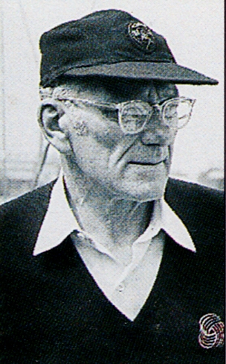
THE SIR FRANCIS CHICHESTER
TRUST

“The Inspiration to Achieve”

MAKE A DONATION

The Sir Francis Chichester Trust is a registered charity that is dependent upon donations to achieve its aim
to inspire young people from Devon to fulfil their potential through challenging outdoor experiences.

By making a donation to the Sir Francis Chichester Trust you are giving young people the opportunity of a life-changing experience.

Your details
Title & Full Name ..................................................................................................................................................................................................
Address ..................................................................................................................................................................................................

..................................................................................................................................................................................................

.............................................................................................................................Postcode....................................................

Telephone ……....................…............................……..... Email ..................................................................................……..

I am pleased to enclose my donation of £ .............................

I enclose my cheque payable to The Sir Francis Chichester Trust

Make your donation worth even more - at no extra cost to you!

Gift Aid allows charities like The Sir Francis Chichester Trust to claim back the tax from the Inland Revenue that you have already paid.
Please tick the box ◻

I am a UK taxpayer and I want The Sir Francis Chichester Trust to treat all donations I make from the
date of this declaration until I notify you otherwise as Gift Aid donations.

Signed …………………………………………………………......….… Date ………….......………

Notes about Gift Aid
1. If in the future your circumstances change and you no longer pay tax on your income and capital gains equal to the tax that the charity reclaims, you can cancel your declaration
2. Please notify us if you change your name or address
3. Please note that you must pay an amount of income tax or capital gains tax equal to or more than the tax that the charity reclaims from your donation in the tax year.

Donations can be sent by bank transfer to:
The Sir Francis Chichester Trust. Sort Code: 30-96-23. Account No: 00209968
Please return this form to info@chichestertrust.org.uk or by post with cheque to:
The Sir Francis Chichester Trust, PO Box 27, Bradninch, Exeter, EX3 9BN

Thank you for your donation
Please tick if you DO NOT require an acknowledgement ◻

